**Creating Table Nobel_win :**

Create table nobel_win (Year Int, Subject varchar(20),Winner varchar(20),Country varchar(20),Category varchar(20));

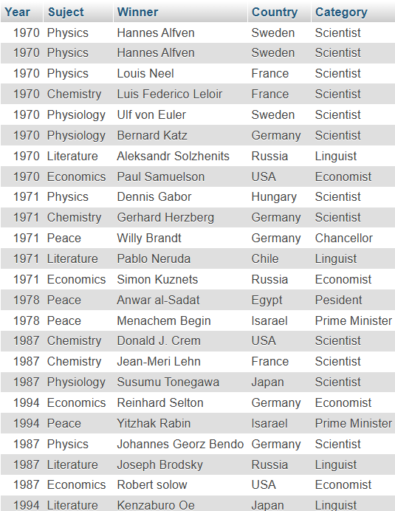

* **Query 1 =**

**Write SQL query to find the Nobel prize winners of the year 1970: return year, subject, and winner.**

* SELECT Year,Suject,Winner FROM nobel_win WHERE Year=1970;

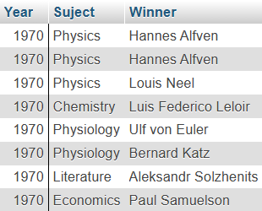

* **Query 2 =**

**Write SQL query to find the Nobel prize winners in chemistry between 1965 and 1975. Begin and end values include year, subject, winner, and country**

* SELECT Year,Suject,Winner,Country FROM nobel_win WHERE Suject="Chemistry" AND Year BETWEEN 1965 AND 1975;

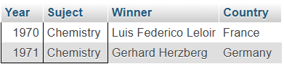

* **Query 3 =**

**Write an SQL query to retrieve the details of the winners whose first name matches with the string ‘Louis’. Return year, subject, winner, country.**

* SELECT Year, Suject, Winner, Country FROM nobel_win WHERE Winner LIKE 'Louis%';

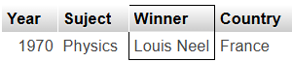

* **Query 4=**

**Write sql query to find Nobel prize winners for the subject that does not begin with the letter ‘P’. Order the result by year, descending and winner in ascending**

* SELECT * FROM nobel_win WHERE Suject NOT LIKE '%P' ORDER by Year DESC, Winner ASC;

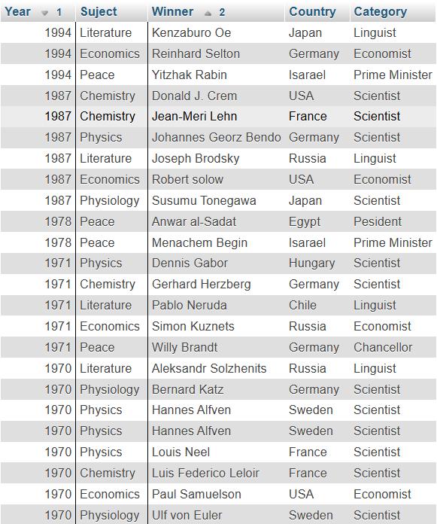

* **Query 5 =**

**Write SQL query to find the details of 1970 Nobel prize winners. Order the result by subject, ascending except for ‘Chemistry’ and ‘Economics’ which will come at the end of the result set. Return year, subject, winner, country, and category.**

* SELECT year, Suject, winner, country, category FROM nobel_win WHERE year = 1970 ORDER BY CASE WHEN Suject IN ('Chemistry', 'Economics') THEN 1 ELSE 0 END, suject ASC;

